DEBATEBOT ARENA
An AI-Powered Interactive Debate Platform
A Project Report Submitted to the
MADURAI KAMARAJ UNIVERSITY, MADURAI
In partial fulfillment of the requirement for the award of the degree of
BACHELOR OF COMPUTER SCIENCE
SUBMITTED BY
SANGEETHA.R (Reg. No: C4S22382)

UNDER THE GUIDANCE OF

DEPARTMENT OF COMPUTER SCIENCE
NPR ARTS AND SCIENCE COLLEGE
NATHAM
2024 - 2027

NPR ARTS AND SCIENCE COLLEGE, NATHAM
DEPARTMENT OF COMPUTER SCIENCE
BONAFIDE CERTIFICATE
Certified that this project report titled “DEBATEBOT ARENA — AN AI-POWERED INTERACTIVE DEBATE PLATFORM” is the bonafide work of R.SANGEETHA (Reg. No: C4S22382) who carried out the project work under my supervision, in partial fulfillment of the requirement for the award of the degree of Bachelor of Computer Applications of Madurai Kamarajar University, Madurai, during the academic year 2024-2027.

Internal Guide | Head of the Department

Submitted for the Viva-Voce examination held at NPR Arts and Science College, Natham on ______________.

Internal Examiner | External Examiner

DECLARATION
I, SANGEETHA.R (Reg. No: C4S22382), hereby declare that this project report entitled “DEBATEBOT ARENA — AN AI-POWERED INTERACTIVE DEBATE PLATFORM” is a record of original work carried out by me under the guidance of [GUIDE NAME TO BE PROVIDED], Department of Computer Science, NPR Arts and Science College, Natham, and that this project work has not previously formed the basis for the award of any degree, diploma, associateship, fellowship or other similar title in this or any other university.
Place: Natham
Date:
SANGEETHA.R (C4S22382)

ACKNOWLEDGEMENT
I praise and thank the Almighty GOD for the blessings and grace showered upon me throughout the course of this project, enabling me to complete it successfully.
I express my sincere and heartfelt thanks to our beloved Principal, NPR Arts and Science College, Natham, for granting me the opportunity to undertake this project work.
I extend my profound gratitude to the Head of the Department, Department of Computer Science, NPR Arts and Science College, Natham, for the encouragement and departmental support extended during the course of this project.
I am deeply grateful to my project guide, [GUIDE NAME TO BE PROVIDED], Department of Computer Science, for the valuable guidance, constant supervision, and constructive suggestions offered throughout the duration of this project.
I also thank all the faculty members of the Department of Computer Science for their support and encouragement.
Finally, I would like to thank my parents, family, and friends for their constant encouragement, patience, and support throughout the successful completion of this project.

ABSTRACT
DebateBot Arena is a web-based interactive platform that allows a user to engage in a structured debate against an artificial-intelligence opponent. The application is built as a modern single-page application using React 19 and is bundled and served using the Vite build tool. The user interface uses Framer Motion for fluid, state-driven animations and Lucide React for a consistent, lightweight icon set, while AI-generated debate responses — which may contain formatted text such as headings, emphasis, and lists — are parsed and rendered using the Marked markdown-parsing library.
The central objective of DebateBot Arena is to provide an accessible environment in which a user can select or propose a debate topic, take a stance, and exchange arguments and counter-arguments with an AI debate opponent in real time. Such a platform has value both as a recreational application and as an educational tool for practising argumentation, critical thinking, and public-speaking preparation, since it allows a learner to rehearse debate scenarios without requiring a second human participant to be available.
This report documents the complete life cycle of the project, covering the existing and proposed systems, requirement analysis, system design (including architecture, data-flow, use-case, activity and entity-relationship diagrams), implementation details of the technology stack actually used in the project, the testing strategy adopted, and the results obtained. Wherever a specific implementation detail — such as the exact AI/LLM service, backend framework, or persistence mechanism — could not be conclusively determined from the project files supplied for this documentation, the relevant section is explicitly marked with the placeholder [DETAIL TO BE PROVIDED] so that it can be completed with the exact information once confirmed.
The project demonstrates the practical application of modern front-end engineering practices — component-based UI design, declarative animation, client-side markdown rendering, and a fast Vite-based development workflow — to build an engaging, AI-assisted debate experience.

TABLE OF CONTENTS
CERTIFICATE ii
DECLARATION iii
ACKNOWLEDGEMENT iv
ABSTRACT v
LIST OF FIGURES xi
LIST OF TABLES xiii
LIST OF ABBREVIATIONS xv
CHAPTER 1 INTRODUCTION 1
1.1 About the Project 1
1.2 Background 1
1.3 Project Overview 1
1.4 Motivation 1
1.5 Problem Statement 1
1.6 Objectives 1
1.7 Scope of the Project 1
1.8 Significance of the Project 1
1.9 Organization of the Report 1
CHAPTER 2 EXISTING SYSTEM AND PROPOSED SYSTEM 6
2.1 Existing System 6
2.2 Limitations of the Existing System 6
2.3 Proposed System 6
2.4 Advantages of the Proposed System 6
2.5 Comparison of Existing and Proposed System 6
CHAPTER 3 SYSTEM ANALYSIS 9
3.1 Requirement Analysis 9
3.2 Functional Requirements 9
3.3 Non-Functional Requirements 9
3.4 Hardware Requirements 9
3.5 Software Requirements 9
3.6 User Requirements 9
3.7 Feasibility Study 9
CHAPTER 4 SYSTEM DESIGN 16
4.1 System Architecture 16
4.2 Module Design 16
4.3 Data Flow Diagram 16
4.4 Use Case Diagram 16
4.5 Use Case Description 16
4.6 Activity Diagram 16
4.7 Entity-Relationship Diagram 16
4.8 Component / Module Interaction 16
CHAPTER 5 IMPLEMENTATION 23
5.1 Technology Stack 23
5.2 Frontend Implementation 23
5.3 Backend / AI-Integration Implementation 23
5.4 Data Management 23
5.5 Error Handling 23
5.6 Configuration 23
5.7 Recommended Project Folder Structure 23
CHAPTER 6 TESTING 28
6.1 Testing Strategy 28
6.2 Unit Testing 28
6.3 Integration Testing 28
6.4 System Testing 28
6.5 Functional and UI Testing 28
6.6 Test Cases 28
6.7 Test Status Summary 28
CHAPTER 7 RESULTS AND DISCUSSION 31
7.1 Implementation Results 31
7.2 Application Output / Major Screens 31
7.3 Feature Demonstration 31
7.4 Observations 31
7.5 Discussion of Results 31
CHAPTER 8 CONCLUSION AND FUTURE ENHANCEMENT 33
8.1 Conclusion 33
8.2 Project Achievements 33
8.3 Limitations 33
8.4 Future Enhancements 33
8.5 Possible Improvements 33
GLOSSARY OF TERMS 36
REFERENCES 38
APPENDIX 39

LIST OF FIGURES
Figure 3.1 Wireframe — Topic Selection Screen (proposed) 9
Figure 3.2 Wireframe — Debate Screen (proposed) 9
Figure 3.3 Wireframe — Debate Summary Screen (proposed) 9
Figure 4.1 System Architecture of DebateBot Arena 16
Figure 4.2 Data Flow Diagram of DebateBot Arena 16
Figure 4.3 Use Case Diagram of DebateBot Arena 16
Figure 4.4 Activity Diagram — Debate Session Flow 16
Figure 4.5 Entity-Relationship Diagram — Conceptual Data Model 16

LIST OF TABLES
Table 2.1 Comparison of Existing System and Proposed System 6
Table 3.1 Functional Requirements 9
Table 3.2 Non-Functional Requirements 9
Table 3.3 Minimum Hardware Requirements 9
Table 3.4 Software Requirements 9
Table 5.1 Confirmed Technology Stack 23
Table 5.2 Recommended src/ Folder Organization 23
Table 6.1 Test Case Design — DebateBot Arena 28
Table G.1 Glossary of Terms Used in This Report 36

LIST OF ABBREVIATIONS
Abbreviation | Expansion
AI | Artificial Intelligence
API | Application Programming Interface
BCA | Bachelor of Computer Applications
DFD | Data Flow Diagram
ER | Entity-Relationship
HMR | Hot Module Replacement
JSX | JavaScript XML
LLM | Large Language Model
SPA | Single Page Application
UI | User Interface
UI/UX | User Interface / User Experience

CHAPTER 1

INTRODUCTION

1.1 About the Project
DebateBot Arena is a web-based application that enables a user to conduct a structured, turn-by-turn debate with an artificial-intelligence opponent inside the browser. Rather than requiring a second human participant, the platform itself generates the opposing side of the argument, allowing the user to practise framing claims, responding to counter-points, and refining an argument in real time.
The application is implemented as a single-page application (SPA) using React 19 and is built and served through the Vite tool-chain. The user interface layer is enhanced with the Framer Motion animation library so that transitions between debate turns, topic selection screens, and result views feel fluid rather than abrupt, and it uses the Lucide React icon set to keep the visual language of the interface consistent and lightweight. Because an AI-generated debate argument frequently benefits from structure — for example, a numbered list of supporting points or emphasis on a key term — the platform renders AI responses through the Marked markdown-parsing library so that such structured text displays correctly rather than as raw, unformatted text.

1.2 Background
Debating is a long-established method for developing critical thinking, structured reasoning, and persuasive communication skills. Traditionally, practising debate requires at least two participants, a moderator, and a shared block of time, which makes regular, on-demand practice difficult for an individual learner. The recent maturity of conversational artificial-intelligence systems has made it practical for a single application to generate a coherent, contextually relevant counter-argument to a user-supplied claim, opening the possibility of an always-available debate partner. DebateBot Arena is motivated by this opportunity: it packages an AI debate opponent inside an approachable, modern web interface so a learner can practise argumentation whenever they choose.

1.3 Project Overview
At a high level, DebateBot Arena presents the user with a topic-selection screen, after which the user and the AI opponent exchange arguments across one or more rounds. Each user submission is processed by the application and forwarded to the response-generation component so that a counter-argument can be produced; the counter-argument is then rendered back to the user, formatted through the markdown pipeline where necessary. The interaction continues for a number of rounds, after which the debate session may be reviewed as a transcript.
The project, as supplied for this documentation, consists of the front-end application scaffold: the Vite configuration, the HTML entry point, the package manifest describing the front-end dependencies (React, Framer Motion, Lucide React, and Marked), and the lint configuration (Oxlint) used to enforce code-quality rules such as the React Hooks rules. The specific application source files (React components, the debate-engine logic, and the AI-integration module) and any backend service were not included among the files made available for this documentation; wherever this report describes such internals, it is described at the level that can be reasonably inferred from the declared dependencies and is explicitly marked with the placeholder [DETAIL TO BE PROVIDED] where a concrete implementation choice would otherwise need to be stated.

1.4 Motivation
- To provide a readily accessible tool for practising argumentation and critical thinking without requiring a second human participant.
- To explore the application of conversational AI as an interactive debate opponent rather than a purely question-answering assistant.
- To build a responsive, animated, modern web interface that makes an inherently text-heavy activity (debating) visually engaging.
- To demonstrate a practical, component-based front-end architecture using current React tooling (React 19 and Vite).

1.5 Problem Statement
Individuals who wish to improve their debating and argumentation skills often lack a convenient way to practise: arranging a human sparring partner is time-consuming, and existing AI chat assistants are typically designed to be agreeable and to directly answer questions rather than to adopt and consistently defend an opposing stance across multiple rounds of a structured debate. There is a need for an application purpose-built around the debate format — topic selection, turn-taking, sustained opposition, and a reviewable transcript — rather than a general-purpose chat interface repurposed for the task.

1.6 Objectives
- To design and build a user interface that allows a user to select or enter a debate topic and take a position on it.
- To enable a structured, turn-based exchange of arguments between the user and an AI-driven opposing participant.
- To render AI-generated responses with correct formatting (headings, emphasis, and lists) using client-side markdown parsing.
- To provide a smooth, animated user experience using a dedicated animation library rather than abrupt UI state changes.
- To maintain a clean, lint-enforced code base using a fast modern build tool suited to iterative front-end development.
- To document the system so that the AI-integration and persistence layers can be completed and evaluated against a defined architecture.

1.7 Scope of the Project
The scope of DebateBot Arena, as evidenced by the project files, covers the client-side web application: topic handling, the turn-based debate interface, animated transitions, icon-based UI affordances, and markdown-based rendering of debate content. The scope statement below distinguishes between what has been confirmed from the supplied files and what would typically be required to complete a production-ready system of this kind.
- In scope (confirmed): A React-based single-page front end; Vite-based development and production build tooling; Framer Motion animation; Lucide React iconography; Marked-based markdown rendering of debate content; Oxlint-enforced code quality rules.
- In scope (typically required, not confirmed in the supplied files — [DETAIL TO BE PROVIDED]): The specific AI/LLM service or model used to generate counter-arguments; any backend API layer; persistence of debate sessions and topics; user authentication.
- Out of scope: Voice-based debate input/output, multiplayer human-vs-human debate, and moderation/scoring by a third-party judge, unless such features are confirmed to exist in the full application source.

1.8 Significance of the Project
DebateBot Arena is significant both as an educational tool and as a demonstration of applied AI-assisted interaction design. Educationally, it lowers the barrier to regular debate practice, which can benefit students preparing for academic debate competitions, public-speaking courses, or general critical-thinking development. From an engineering perspective, the project illustrates how a modern React front end can be composed from a small number of focused libraries — an animation library, an icon library, and a markdown renderer — to deliver a polished, purpose-built experience for a specific interaction pattern (turn-based argumentation) rather than a generic chat window.

1.9 Organization of the Report
The remainder of this report is organized as follows. Chapter 2 discusses the existing systems related to debate practice and AI chat assistants, and positions the proposed system, DebateBot Arena, relative to them. Chapter 3 presents the system analysis, including functional and non-functional requirements and a feasibility study. Chapter 4 presents the system design, including the system architecture, data-flow diagrams, use-case and activity diagrams, and the conceptual entity-relationship model. Chapter 5 describes the implementation, covering the confirmed technology stack and the front-end structure. Chapter 6 describes the testing strategy and presents test-case tables. Chapter 7 presents the results and a discussion of the implementation. Chapter 8 concludes the report and outlines the limitations and future enhancements. The report closes with a list of references and an appendix containing configuration excerpts and supporting material.
CHAPTER 2

EXISTING SYSTEM AND PROPOSED SYSTEM

2.1 Existing System
At present, a person who wishes to practise debating typically relies on one of the following approaches: arranging a live debate with a fellow student or colleague, joining a formal debate club or classroom exercise, or using a general-purpose AI chat assistant to discuss a topic. Each of these approaches has practical limitations when the specific goal is repeated, on-demand debate practice.
- Human debate partners: Effective, but require both participants to be available at the same time, and regular practice sessions are difficult to sustain.
- Debate clubs / classroom exercises: Structured and valuable, but limited to scheduled sessions and a fixed group size.
- General-purpose AI chat assistants: Widely available, but are generally designed to be cooperative and informative rather than to consistently hold and defend an opposing position across multiple structured rounds; they also lack a dedicated interface for topic selection, turn-taking, or a reviewable debate transcript.

2.2 Limitations of the Existing System
- No always-available, one-on-one opposing participant for structured debate practice.
- General-purpose chat assistants do not enforce a debate format (stance, rebuttal, turn order) and may agree with the user rather than argue against them.
- No dedicated, purpose-built interface for selecting a topic, tracking rounds, and reviewing a debate transcript.
- Scheduling a human debate partner introduces friction that discourages frequent practice.

2.3 Proposed System
The proposed system, DebateBot Arena, addresses the above limitations by providing a dedicated, always-available web application in which the user debates directly against an AI-driven opponent within a purpose-built, turn-based interface. The user selects or enters a topic, the system manages the turn-by-turn exchange of arguments, and AI-generated counter-arguments are returned and rendered — including any structured formatting such as lists or emphasis — through a markdown-rendering pipeline. The interface uses animated transitions to make the flow between turns clear and engaging, and a consistent icon set to support quick recognition of actions such as starting a debate, submitting an argument, or ending a session.

2.4 Advantages of the Proposed System
- Available on demand, without needing to schedule a second human participant.
- Purpose-built turn-based interface, rather than a repurposed general chat window.
- Consistent, correctly formatted rendering of AI responses via client-side markdown parsing.
- Smooth, animated user experience that keeps the user oriented within the debate flow.
- Modern, fast development workflow (Vite) that supports rapid iteration on the interface.
- Lint-enforced code quality (Oxlint with React-specific rules) to reduce common
Aspect | Existing System | Proposed System — DebateBot Arena
Availability | Depends on a human partner's schedule | Available at any time, on demand
Opponent behaviour | General chat assistants tend to agree or inform, not consistently oppose | AI opponent is intended to sustain an opposing stance across rounds
Interface | General chat window or in-person setting | Dedicated, animated, turn-based debate interface
Formatting of responses | Plain text or inconsistent formatting | Markdown-rendered responses (headings, emphasis, lists)
Session review | Often not recorded | Debate transcript intended to be reviewable within the session
- React bugs such as incorrect Hook usage.

2.5 Comparison of Existing and Proposed System
Table 2.1: Comparison of Existing System and Proposed System
CHAPTER 3

SYSTEM ANALYSIS

3.1 Requirement Analysis
Requirement analysis for DebateBot Arena was carried out by examining the confirmed project configuration and dependency files. The functional and non-functional requirements below are grouped so that requirements directly evidenced by the project files are distinguished from requirements that a complete debate platform of this kind would typically need, which are marked [DETAIL TO BE PROVIDED] pending confirmation against the full application source.

3.2 Functional Requirements
Table 3.1: Functional Requirements
ID | Requirement | Status
FR-1 | The system shall allow a user to select or enter a debate topic. | Core UI requirement
FR-2 | The system shall allow a user to submit an argument or rebuttal as text. | Core UI requirement
FR-3 | The system shall generate an AI counter-argument in response to the user's submission. | [DETAIL TO BE PROVIDED — AI integration]
FR-4 | The system shall render AI responses with markdown formatting (headings, lists, emphasis) correctly. | Confirmed — Marked library present
FR-5 | The system shall display the sequence of turns/messages that make up the debate. | Core UI requirement
FR-6 | The system shall provide animated transitions between debate states/turns. | Confirmed — Framer Motion present
FR-7 | The system shall allow a user to end a debate session and view a summary/transcript. | Core UI requirement
FR-8 | The system shall persist debate sessions between visits. | [DETAIL TO BE PROVIDED — persistence layer]
FR-9 | The system shall support user accounts/authentication. | [DETAIL TO BE PROVIDED — not evidenced]

3.3 Non-Functional Requirements
Table 3.2: Non-Functional Requirements
Category | Requirement
Usability | The interface shall be simple enough for a first-time user to start a debate without instructions.
Performance | The development build shall provide fast reload/hot-module-replacement via Vite for efficient iteration; production build shall be bundled/minified by Vite.
Responsiveness | The interface shall render correctly on common desktop and mobile viewport widths [DETAIL TO BE PROVIDED — dependent on component-level CSS].
Maintainability | The code base shall be checked against React-specific lint rules (rules-of-hooks, component-export conventions) using Oxlint.
Portability | The application shall run in any modern evergreen web browser supporting ES modules.
Reliability | The system shall handle a failed or delayed AI response gracefully [DETAIL TO BE PROVIDED — error-handling strategy].
Security | Any AI/API credentials shall not be exposed to the client bundle [DETAIL TO BE PROVIDED — depends on backend/proxy design].

3.4 Hardware Requirements
Table 3.3: Minimum Hardware Requirements
Component | Development Environment | End-User (Client)
Processor | Dual-core 2 GHz or higher | Any processor capable of running a modern browser
RAM | 4 GB minimum (8 GB recommended) | 2 GB minimum
Storage | 500 MB free space for project and dependencies | Negligible (browser cache only)
Network | Internet connection for package installation and AI requests | Internet connection required for AI responses

3.5 Software Requirements
Table 3.4: Software Requirements
Category | Software / Technology
Operating System | Windows / Linux / macOS (any OS supporting Node.js)
Runtime | Node.js (compatible with Vite 8.x and React 19.x)
Package Manager | npm
Build Tool | Vite ^8.2.0 with @vitejs/plugin-react
Front-End Library | React ^19.2.8, React DOM ^19.2.8
Animation Library | Framer Motion ^13.0.0
Icon Library | Lucide React ^1.30.0
Markdown Parser | Marked ^18.0.9
Linter | Oxlint ^1.75.0 (react, oxc plugins)
Browser | Any modern evergreen browser (Chrome, Edge, Firefox, Safari)
AI / LLM Service | [DETAIL TO BE PROVIDED — not evidenced in supplied files]
Backend Framework | [DETAIL TO BE PROVIDED — not evidenced in supplied files]
Database | [DETAIL TO BE PROVIDED — not evidenced in supplied files]

3.6 User Requirements
The primary user of DebateBot Arena is an individual who wants to practise debating a topic. Such a user requires a simple way to start a debate quickly, understand whose turn it is at any moment, read the AI's counter-arguments clearly (including any formatted content), and end the session with a usable summary of what was discussed. No specialised technical knowledge is required of the end user.

3.7 Feasibility Study
3.7.1 Technical Feasibility
The project is technically feasible using widely adopted, actively maintained technologies. React 19 and Vite 8 form a mature, well-documented front-end foundation; Framer Motion and Lucide React are established libraries for animation and iconography respectively; and Marked is a lightweight, dependency-free markdown parser suitable for rendering AI-generated text in the browser. Completing the AI-integration and any backend/persistence layer is technically feasible using any of the widely available conversational-AI APIs, though the specific choice is [DETAIL TO BE PROVIDED].
3.7.2 Economic Feasibility
The front-end technologies used are open-source and free to use, which keeps development cost limited primarily to development time and, if an external AI/LLM API is used for response generation, the usage cost of that API. As an academic project, the economic overhead is low and within the scope of a final-year project budget.
3.7.3 Operational Feasibility
The application is operable through a standard web browser and does not require the end user to install any additional software, which supports ease of adoption. The development workflow (Vite's development server with hot-module-replacement) supports efficient iterative development, and the Oxlint configuration helps the project maintain consistent code quality as it grows.

3.8 Proposed User Interface / Screen Design
This section presents the planned screen layout for DebateBot Arena at a wireframe level of detail, derived from the functional requirements in Section 3.2 and the confirmed front-end dependencies. These are design-stage wireframes prepared to guide implementation and review, and are explicitly not screenshots of a running application; actual screenshots should replace or supplement this section once the application is run (see Section 7.2).
3.8.1 Topic Selection Screen
The topic-selection screen is the entry point of the application. It presents the DebateBot Arena header, a short prompt inviting the user to choose a topic, a small set of suggested topic cards, and a text field allowing the user to enter a custom topic. A prominent “Start Debate” action begins the session once a topic has been chosen.
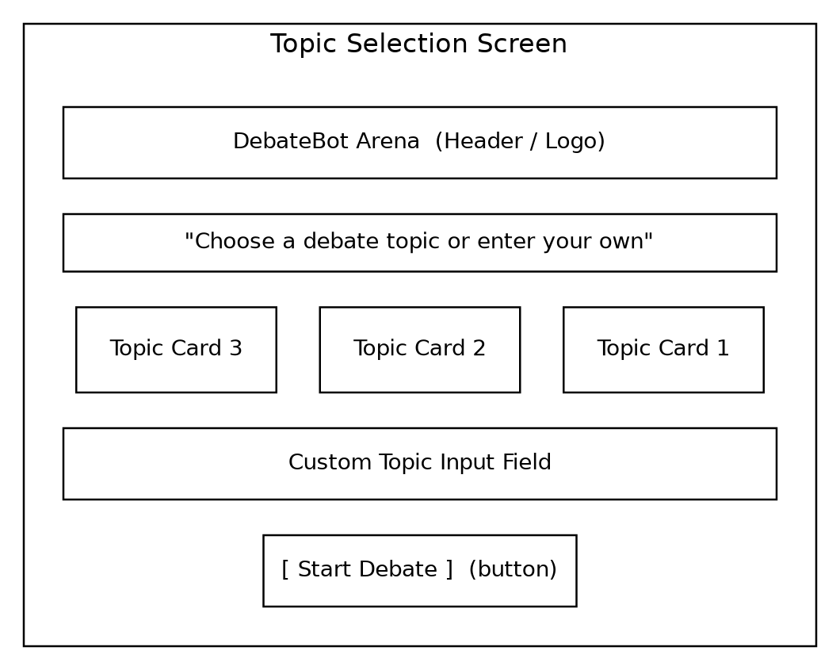
Figure 3.1: Wireframe — Topic Selection Screen (proposed)
3.8.2 Debate Screen
The debate screen is the core interaction surface. It displays the active topic and the current round number, the AI opponent's most recent response (rendered through the markdown pipeline so that any structured formatting displays correctly), the user's own most recent submission, a text input box for the next argument, and a submit action. Framer Motion transitions are intended to animate the appearance of each new turn as it is added to the transcript.
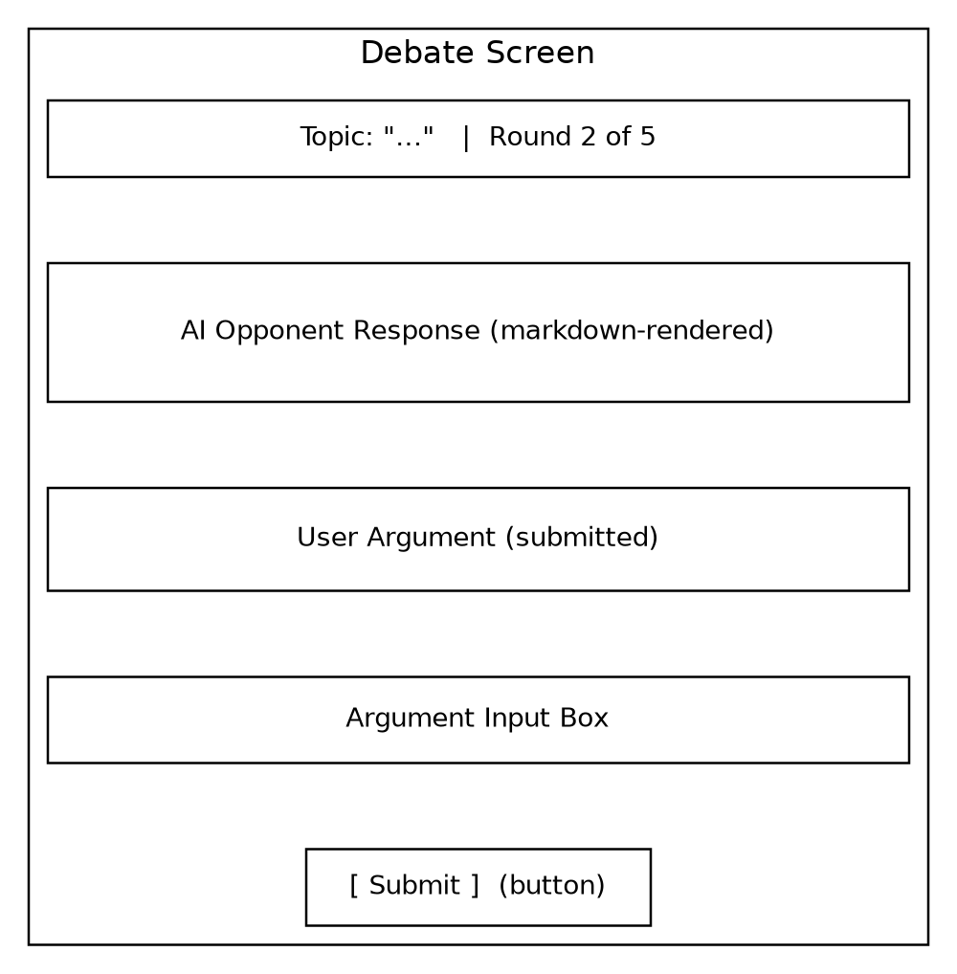
Figure 3.2: Wireframe — Debate Screen (proposed)
3.8.3 Debate Summary Screen
Once a debate session ends — either because the configured number of rounds has been reached or because the user chooses to end it — the summary screen displays the topic, the full turn-by-turn transcript in a scrollable list, and an action allowing the user to start a new debate.
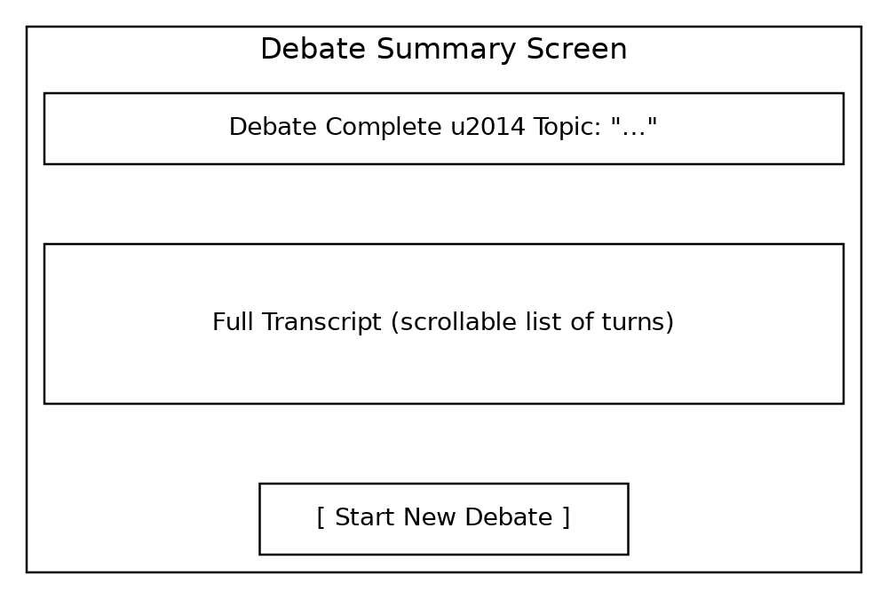
Figure 3.3: Wireframe — Debate Summary Screen (proposed)
CHAPTER 4

SYSTEM DESIGN

4.1 System Architecture
DebateBot Arena follows a client-centric, component-based architecture typical of a modern React single-page application. The presentation layer is composed of React components that are bundled and served by Vite. Two supporting front-end layers sit alongside the core UI components: an animation layer built on Framer Motion, which drives transitions between debate states, and an icon layer built on Lucide React, which supplies the visual iconography used throughout the interface. User actions are handled by a debate-engine layer responsible for session and turn-state management; this layer is responsible for forwarding the user's argument to an AI response-generation module and receiving the generated counter-argument back. Before display, AI-generated text is passed through a markdown-rendering layer built on the Marked library so that any structured formatting is rendered correctly. The exact internal design of the AI response-generation module — whether it calls a third-party AI/LLM API directly from the client, or via a backend proxy — was not evidenced in the project files supplied for this documentation and is marked accordingly in the diagram below.
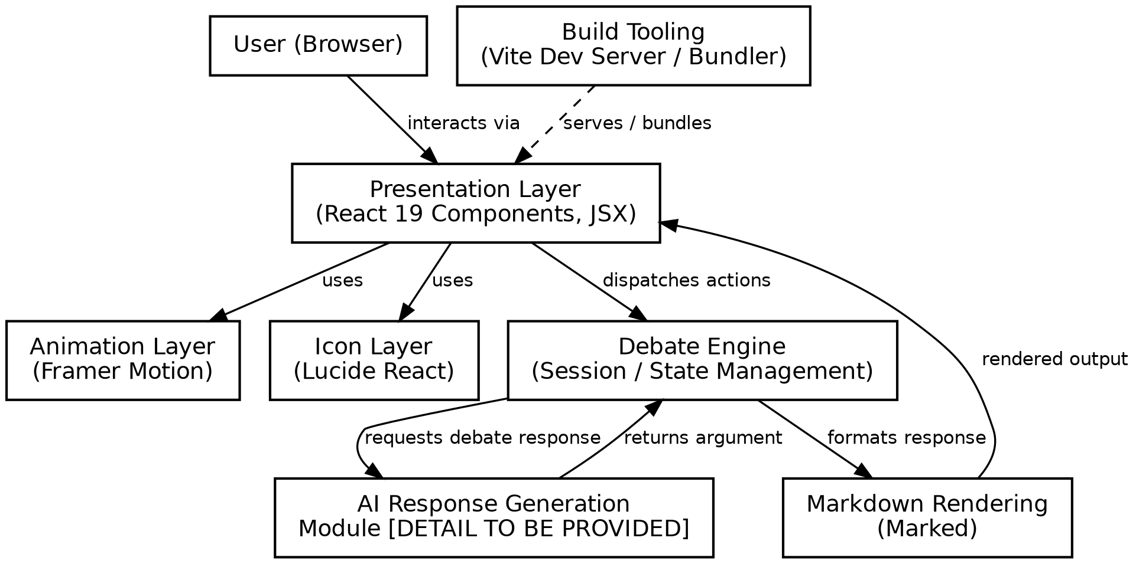
Figure 4.1: System Architecture of DebateBot Arena

4.2 Module Design
The system can be considered in terms of the following logical modules. Each module is described in terms of its responsibility; modules whose internal implementation could not be confirmed from the supplied files are marked accordingly.
- Topic Selection Module — presents available/suggested debate topics and accepts a user-entered custom topic.
- Debate Session Module — manages the state of an active debate: current round, whose turn it is, and the running transcript.
- Argument Submission Module — captures and validates the user's textual argument before it is sent for processing.
- AI Response Generation Module — produces the AI opponent's counter-argument for the current round [DETAIL TO BE PROVIDED — specific AI/LLM integration].
- Markdown Rendering Module — converts AI-generated markdown text into formatted HTML for display, using the Marked library.
- Animation/Transition Module — governs the visual transitions between screens and turns, using Framer Motion.
- Session Summary Module — presents a reviewable transcript once a debate session has ended.

4.3 Data Flow Diagram
The data-flow diagram below illustrates, at a conceptual level, how information moves between the user and the principal processes of the system: session management, argument processing, AI response generation, and output rendering, together with the conceptual data stores for topics and session/message data. The data-store design shown here is conceptual; the actual persistence mechanism (if any) used by the deployed application is [DETAIL TO BE PROVIDED].
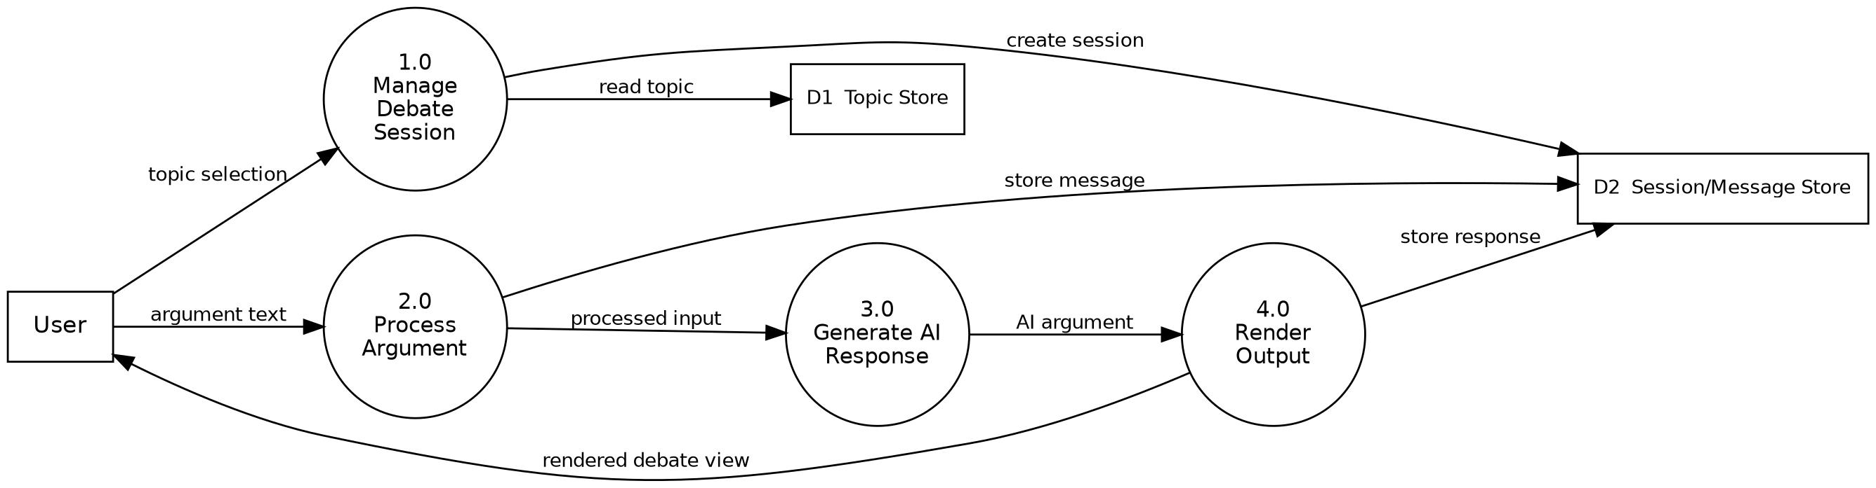
Figure 4.2: Data Flow Diagram of DebateBot Arena

4.4 Use Case Diagram
The use-case diagram identifies the principal interactions available to the user: selecting a debate topic, starting a debate session, submitting an argument, viewing the AI's counter-argument, viewing the debate transcript, and ending the debate session.
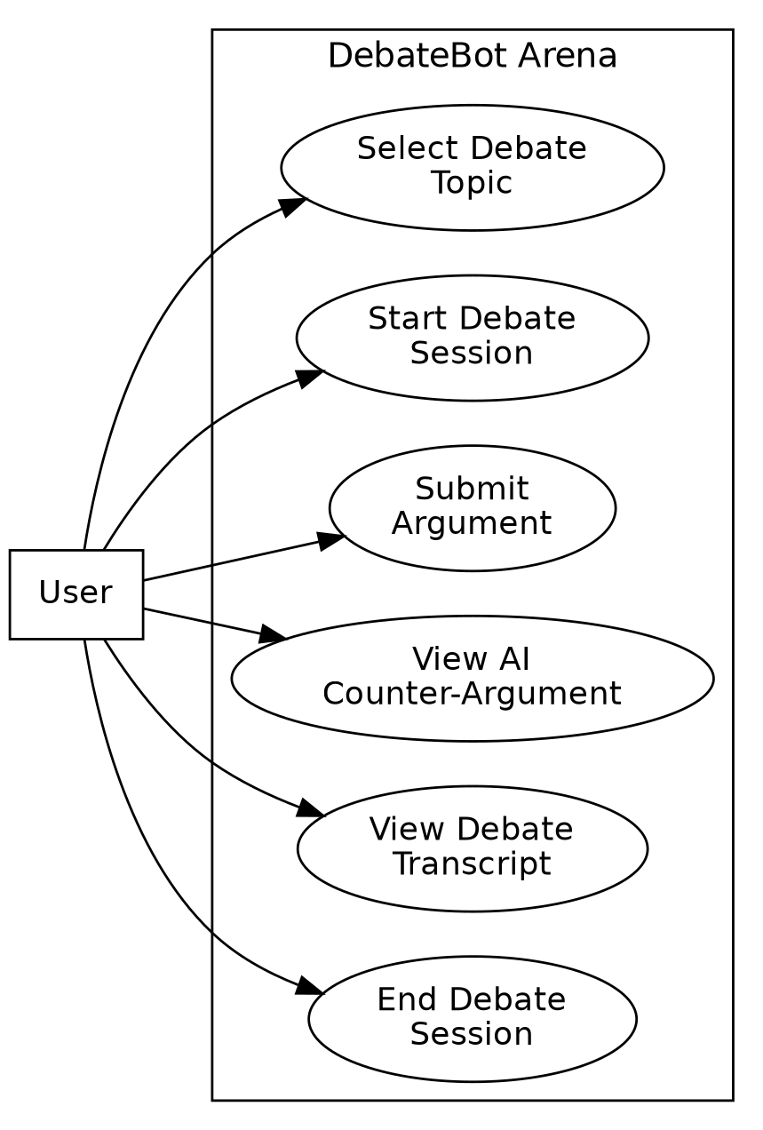
Figure 4.3: Use Case Diagram of DebateBot Arena

4.5 Use Case Description
Use Case: Submit Argument. Actor: User. Precondition: An active debate session exists and it is the user's turn. Main flow: (1) the user types an argument into the input area; (2) the user submits the argument; (3) the debate engine forwards the argument to the AI response-generation module; (4) the AI module returns a counter-argument; (5) the counter-argument is rendered to the user through the markdown-rendering pipeline; (6) control returns to the user for the next round, or the session ends if the configured number of rounds has been reached. Postcondition: the transcript is updated with both the user's argument and the AI's response.

4.6 Activity Diagram
The activity diagram below traces the flow of a single debate session from launch through repeated rounds of argument submission and AI response, to the final display of the debate summary.
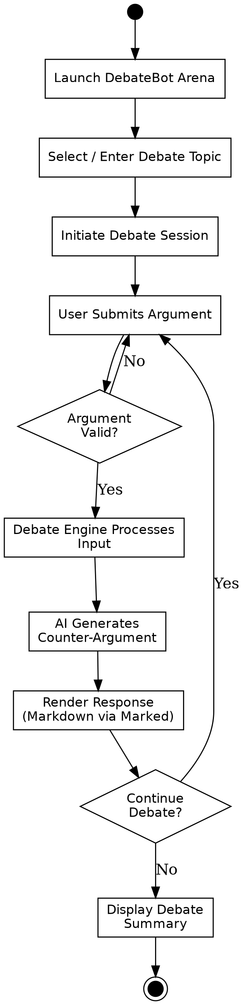
Figure 4.4: Activity Diagram — Debate Session Flow

4.7 Entity-Relationship (Data Model) Diagram
Although the specific persistence layer used by DebateBot Arena was not evidenced in the supplied project files, the entity-relationship diagram below presents the conceptual data model that a complete implementation of the described functionality would require: a User who initiates one or more Debate Sessions, each Debate Session being based on one Topic and containing many Messages (each Message being attributable either to the user or to the AI opponent). This model should be verified and adjusted against the actual persistence implementation once confirmed.
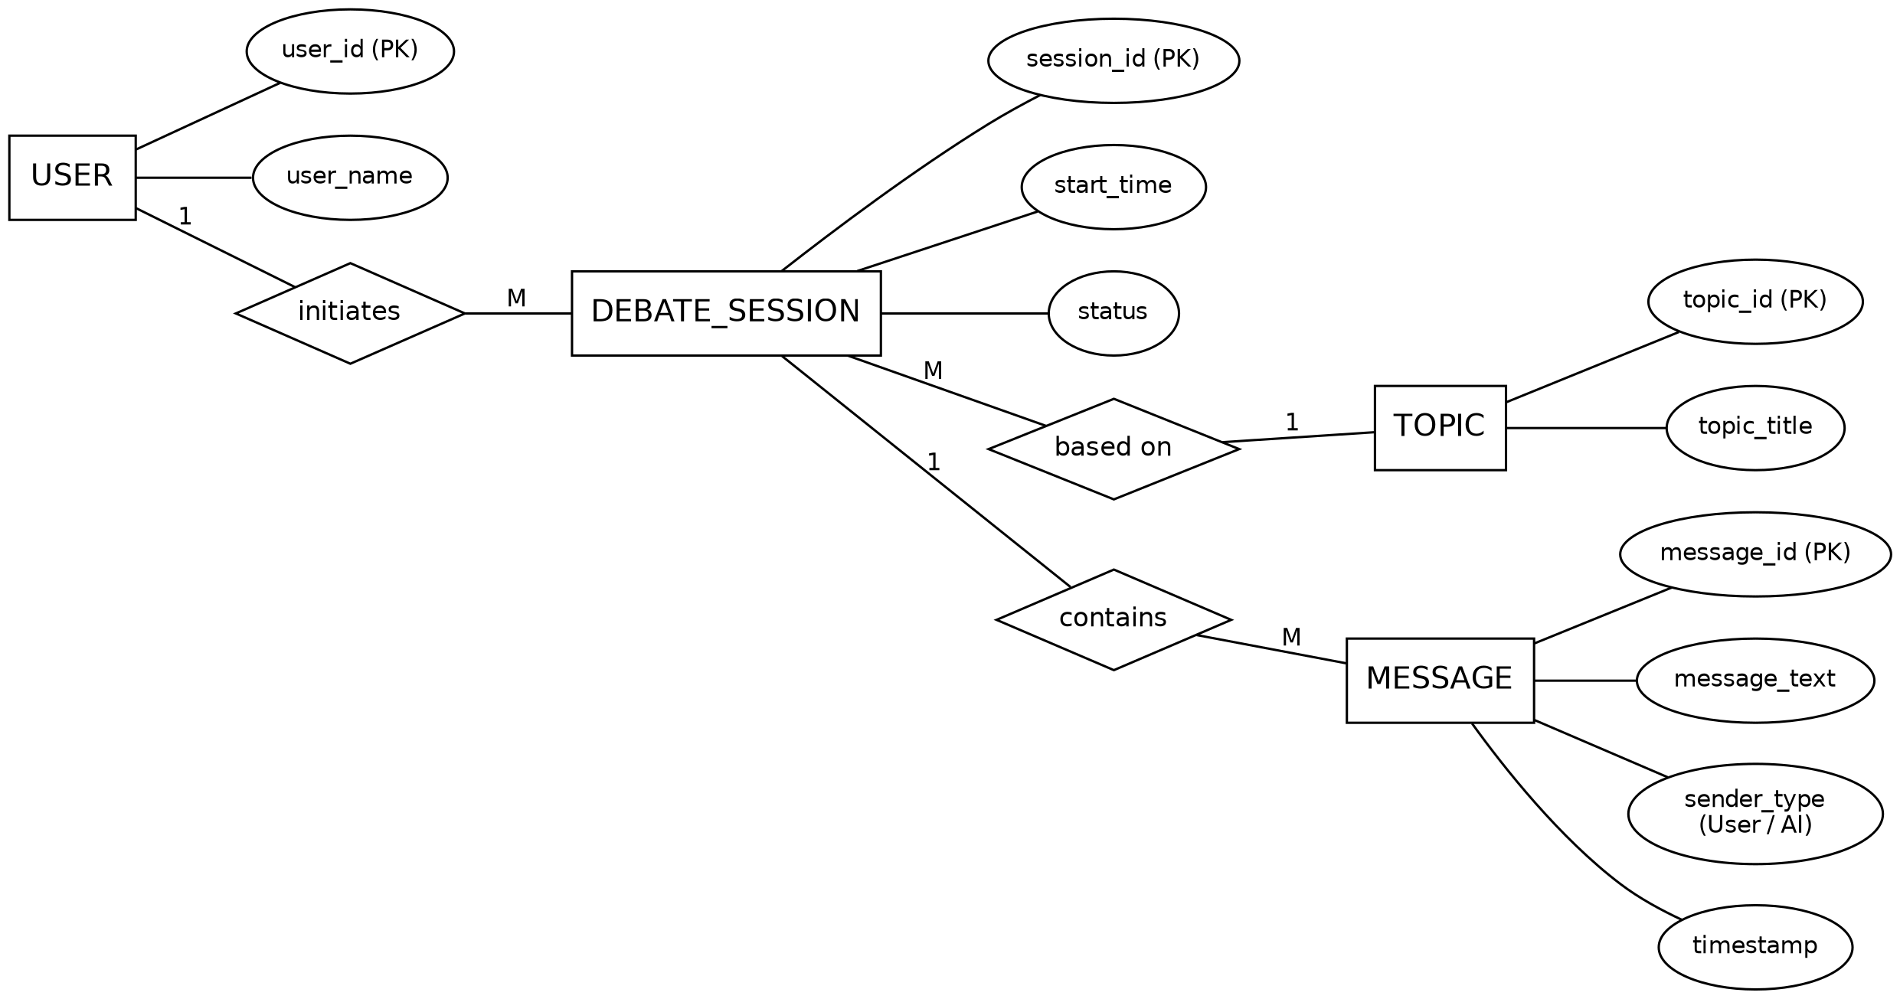
Figure 4.5: Entity-Relationship Diagram — Conceptual Data Model of DebateBot Arena

4.8 Component / Module Interaction
Within the front end, the debate-engine layer acts as the coordination point between the presentation layer and the AI response-generation module. UI components dispatch user actions (such as “submit argument”) to this layer; the layer updates the session state, requests a new AI response, and, once the response is available, hands the raw markdown text to the rendering layer before the updated transcript is passed back down to the presentation components for display. This unidirectional-ish flow of data — UI action up, updated state and rendered content down — mirrors the general data-flow pattern encouraged by React's component model.
CHAPTER 5

IMPLEMENTATION

5.1 Technology Stack
The implementation of DebateBot Arena, as evidenced by the supplied project configuration files (package.json, package-lock.json, vite.config.js, index.html, and .oxlintrc.json), uses the following confirmed technology stack.
Table 5.1: Confirmed Technology Stack
Layer | Technology | Version
UI Library | React / React DOM | ^19.2.8
Build Tool | Vite | ^8.2.0
React Build Plugin | @vitejs/plugin-react | ^6.0.4
Animation | Framer Motion | ^13.0.0
Icons | Lucide React | ^1.30.0
Markdown Parsing | Marked | ^18.0.9
Linting | Oxlint (react, oxc plugins) | ^1.75.0
Type Hints (dev) | @types/react, @types/react-dom | ^19.2.17 / ^19.2.3

The project is configured as an ES module package (“type”: “module” in package.json) with npm scripts for development (vite), production build (vite build), linting (oxlint), and previewing a production build (vite preview). The HTML entry point (index.html) mounts the application into a single root <div id="root"> element and loads the application through /src/main.jsx as an ES module, which is the standard Vite + React bootstrap pattern.

5.2 Frontend Implementation
5.2.1 Component-Based UI
Following the standard React 19 architecture implied by the project dependencies, the interface is expected to be composed of functional components using Hooks for state and side-effect management. The Oxlint configuration explicitly enforces the react/rules-of-hooks rule as an error, indicating that the project intends to strictly follow the React Hooks usage rules (Hooks called only at the top level of a function component, not inside loops, conditions, or nested functions), and enables react/only-export-components as a warning (with constant exports allowed), which is a convention that keeps React Fast Refresh working reliably during development.
5.2.2 Animation Layer
Framer Motion (^13.0.0) is declared as a direct dependency, indicating that UI transitions — such as a debate message appearing, a topic card being selected, or a screen transition between the topic-selection view and the active debate view — are implemented declaratively using Framer Motion's motion components and animation props, rather than through manual CSS transitions or imperative DOM manipulation.
5.2.3 Iconography
Lucide React (^1.30.0) supplies the icon components used across the interface. Using a single, consistent icon library across actions such as starting a debate, submitting an argument, and ending a session helps keep the visual language of the application coherent.
5.2.4 Markdown Rendering of AI Responses
The inclusion of Marked (^18.0.9) as a direct dependency indicates that AI-generated debate responses are not treated as plain text; instead, they are parsed as markdown and rendered as formatted HTML. This allows the AI opponent's response to include structured elements — for example, a bolded key claim followed by a bulleted list of supporting points — and have them display correctly to the user rather than showing literal markdown syntax characters.
5.2.5 Build and Development Tooling
Vite ^8.2.0, together with @vitejs/plugin-react, provides the development server (with hot-module-replacement for a fast edit-refresh cycle) and the production build pipeline (bundling and minifying the application for deployment). The vite.config.js file registers the React plugin using Vite's defineConfig helper, which is the standard minimal configuration for a Vite + React project.

5.3 Backend / AI-Integration Implementation
The files supplied for this documentation (the .gitignore, package manifest and lock file, index.html, vite.config.js, .oxlintrc.json, and README.md) describe only the front-end application scaffold. No backend service source, server-side route definitions, API-key configuration, or AI/LLM client-integration code was present among the supplied files. Consequently, the following implementation aspects cannot be confirmed and are marked as placeholders pending access to the complete application source:
- [DETAIL TO BE PROVIDED] — The specific AI/LLM provider or model used to generate the AI opponent's counter-arguments.
- [DETAIL TO BE PROVIDED] — Whether AI requests are issued directly from the client or proxied through a backend service (recommended, to avoid exposing API credentials in the browser).
- [DETAIL TO BE PROVIDED] — The mechanism, if any, used to persist debate sessions, topics, or transcripts between visits (e.g. browser storage, a database, or no persistence).
- [DETAIL TO BE PROVIDED] — Any user-authentication mechanism.
These aspects should be completed from the actual application source before this chapter is treated as a final implementation record; the architecture and module design presented in Chapter 4 provide a reasonable structure within which to document them once available.

5.4 Data Management
At the front-end level, the debate session state (current topic, round number, and the sequence of user/AI messages) is expected to be held in React component state (or a shared state/context) for the duration of a session, consistent with standard React application design. Whether this state is additionally persisted outside of the browser session is [DETAIL TO BE PROVIDED].

5.5 Error Handling
A production-quality implementation of the AI response-generation flow would typically need to handle cases such as a slow or failed AI request, an empty or invalid user submission, and a network interruption, by displaying an appropriate message to the user and allowing the user to retry. The specific error-handling logic implemented in DebateBot Arena is [DETAIL TO BE PROVIDED], as it depends on source files not included in this documentation exercise.

5.6 Configuration
The project's build behaviour is configured through vite.config.js, which registers the @vitejs/plugin-react plugin using Vite's defineConfig helper. Code-quality rules are configured through .oxlintrc.json, which enables the react and oxc Oxlint plugins and sets react/rules-of-hooks to error severity and react/only-export-components to warn severity (allowing constant exports). No environment-variable file (for example, an .env file defining an AI API endpoint or key) was present among the supplied files.

5.7 Recommended Project Folder Structure
The supplied files did not include the application's src/ directory, so the internal component organization could not be confirmed. The structure below is a recommended organization for a project of this scope, following common React + Vite conventions, and is presented as guidance for completing the implementation rather than as a confirmed structure.
Table 5.2: Recommended src/ Folder Organization (proposed)
Path | Purpose
src/main.jsx | Application entry point; mounts the root React component into index.html.
src/App.jsx | Top-level component; manages routing/screen switching between topic selection, debate, and summary views.
src/components/ | Reusable presentational components (TopicCard, MessageBubble, ArgumentInput, ActionButton, etc.).
src/screens/ | Screen-level components (TopicSelectionScreen, DebateScreen, SummaryScreen).
src/engine/ | Debate-session and turn-state management logic (the “Debate Engine” module in Figure 4.1).
src/ai/ | AI response-generation integration [DETAIL TO BE PROVIDED — not present in supplied files].
src/utils/ | Shared helper functions, e.g. markdown-rendering wrapper around Marked, input validation.
src/styles/ | Global and component-level styling.
public/ | Static assets such as the favicon referenced in index.html.
CHAPTER 6

TESTING

6.1 Testing Strategy
Testing for DebateBot Arena is organized around the standard levels applicable to a React single-page application: unit testing of individual components and logic, integration testing of component/module interaction (particularly the flow between argument submission and rendered AI response), system testing of the complete user journey from topic selection to session summary, and functional and UI testing to confirm that the interface behaves and appears as intended. The test cases below are presented as the planned/designed test cases for the confirmed functionality of the project; the Actual Result and Status columns are left as placeholders to be completed once the tests are executed against a running build, so that no result is reported without having actually been observed.

6.2 Unit Testing
Unit testing focuses on individual React components and pure functions in isolation — for example, a component that renders a single debate message, or a utility function that validates a user's submitted argument text before it is sent onward.

6.3 Integration Testing
Integration testing verifies that modules work correctly together — for example, that submitting an argument in the UI correctly triggers the debate-engine state update, that the AI response-generation module's output is correctly handed to the markdown-rendering module, and that the rendered output is correctly inserted back into the transcript view.

6.4 System Testing
System testing exercises the complete application end-to-end: launching the application, selecting a topic, completing multiple rounds of argument exchange, and reviewing the final transcript.

6.5 Functional and UI Testing
Functional testing confirms that each documented functional requirement (Section 3.2) behaves correctly, while UI testing confirms that animated transitions, icons, and markdown-rendered content display correctly across supported browsers and, where applicable, different screen sizes.

6.6 Test Cases
Table 6.1: Test Case Design — DebateBot Arena
TC ID | Test Description | Input | Expected Result | Actual Result / Status
TC-01 | Application loads successfully | Open the application URL | Root UI renders without console errors | [DETAIL TO BE PROVIDED]
TC-02 | Select a debate topic | Choose a topic from the topic-selection screen | Selected topic is shown and debate session becomes active | [DETAIL TO BE PROVIDED]
TC-03 | Enter a custom topic | Type a custom topic and confirm | Custom topic is accepted and used for the session | [DETAIL TO BE PROVIDED]
TC-04 | Submit a valid argument | Type a non-empty argument and submit | Argument appears in transcript; AI response is requested | [DETAIL TO BE PROVIDED]
TC-05 | Submit an empty argument | Submit with no text entered | Submission is blocked / validation message shown | [DETAIL TO BE PROVIDED]
TC-06 | AI response rendering | Receive an AI response containing markdown (e.g. a bullet list) | Response displays as formatted HTML, not raw markdown syntax | [DETAIL TO BE PROVIDED]
TC-07 | Turn transition animation | Complete a round and move to the next turn | Transition animates smoothly without layout glitches | [DETAIL TO BE PROVIDED]
TC-08 | End debate session | Trigger end-of-session action | Session summary/transcript view is displayed | [DETAIL TO BE PROVIDED]
TC-09 | Icon rendering | Load any screen containing action icons | All icons render correctly with no missing assets | [DETAIL TO BE PROVIDED]
TC-10 | Production build | Run ‘vite build’ | Build completes without errors and produces a deployable bundle | [DETAIL TO BE PROVIDED]
TC-11 | Lint compliance | Run ‘oxlint’ against the source | No react/rules-of-hooks violations reported | [DETAIL TO BE PROVIDED]
TC-12 | Long argument input | Submit an argument of several hundred words | Input is accepted and displayed without breaking layout | [DETAIL TO BE PROVIDED]
TC-13 | Network delay on AI response | Simulate a slow AI response | A loading indicator is shown; UI remains responsive | [DETAIL TO BE PROVIDED]
TC-14 | Browser resize / responsiveness | Resize browser window to a mobile width | Layout adapts without overlapping elements | [DETAIL TO BE PROVIDED]

6.7 Test Status Summary
The table above defines eleven representative test cases covering application load, topic handling, argument submission and validation, AI-response rendering, UI animation, session completion, iconography, the production build process, and lint compliance. As the AI-integration and full component source were not available for this documentation exercise, the Actual Result and Status columns are intentionally left as placeholders; they should be completed by executing each test case against the running application and recording the observed outcome, rather than an assumed one.
CHAPTER 7

RESULTS AND DISCUSSION

7.1 Implementation Results
The configuration and dependency files supplied for this documentation confirm that a working Vite + React 19 project scaffold for DebateBot Arena has been established, with the animation, iconography, and markdown-rendering dependencies already declared and version-pinned in package-lock.json. This confirms that the foundational front-end tooling for the application is in place and installable via a standard ‘npm install’ followed by ‘npm run dev’ for development or ‘npm run build’ for a production bundle.

7.2 Application Output / Major Screens
No screenshots of the running DebateBot Arena application were included among the files supplied for this documentation, and in keeping with the requirement not to invent or fabricate visual evidence, no screenshots are reproduced in this chapter. Once the application is run (via ‘npm run dev’ or a deployed build), screenshots of at least the following screens should be captured and inserted here: the topic-selection screen, an in-progress debate exchange (showing both a user argument and a markdown-rendered AI response), and the end-of-session transcript/summary screen. [DETAIL TO BE PROVIDED — application screenshots]

7.3 Feature Demonstration
Based on the confirmed dependency set, the application is expected to demonstrate the following features once run: selection or entry of a debate topic; turn-based submission of arguments; AI-generated counter-arguments rendered with correct markdown formatting; animated transitions between turns and screens; and a consistent icon-based action set. Demonstration of the AI counter-argument generation specifically depends on the AI-integration module, which was not part of the supplied files.

7.4 Observations
- The dependency set is deliberately small and focused — one animation library, one icon library, and one markdown parser — which keeps the front-end bundle lean while still addressing the three concerns (motion, iconography, and rich-text rendering) that a debate interface benefits from.
- The presence of the react/rules-of-hooks Oxlint rule set to ‘error’ indicates an intent to enforce correct Hook usage strictly during development, which helps prevent a common class of React bugs.
- The project name recorded internally in package.json (“sangeetha-project”) and in the HTML <title> matches the default Vite scaffold naming pattern and has not yet been renamed to reflect the DebateBot Arena product name; this is a cosmetic item worth updating before final submission or deployment.

7.5 Discussion of Results
The evidence available confirms that the front-end foundation of DebateBot Arena is technically sound and uses current, well-supported libraries appropriate to the stated goal of an animated, AI-opposed debate interface. The principal open question, from a documentation standpoint, is the AI-integration and any backend/persistence layer, since no corresponding source files were supplied. A complete evaluation of the system's behaviour — including the quality and consistency of the AI-generated counter-arguments — requires access to that layer and to a running instance of the application, and is recommended as the immediate next step before this report's placeholder sections are finalized.
CHAPTER 8

CONCLUSION AND FUTURE ENHANCEMENT

8.1 Conclusion
DebateBot Arena sets out to provide an accessible, purpose-built web platform for practising structured debate against an AI opponent. The project files supplied for this documentation confirm that a modern, well-structured React 19 front-end foundation has been established using Vite for tooling, Framer Motion for animation, Lucide React for iconography, and Marked for markdown rendering of AI-generated content, with Oxlint enforcing React-specific code-quality rules. This foundation is well suited to the stated goal of a smooth, engaging, turn-based debate interface.
The AI response-generation logic and any backend or persistence layer were not included among the files available for this documentation exercise; these components are essential to the project's core value proposition (an AI opponent that can sustain an opposing argument) and should be documented and evaluated as a priority once their source is available. With that caveat, the project as scaffolded demonstrates sound technology choices and a clear architectural direction for the interactive debate experience it is intended to deliver.

8.2 Project Achievements
- Established a modern, fast React 19 + Vite 8 front-end project structure.
- Selected and integrated an appropriate, focused set of front-end libraries for animation (Framer Motion), iconography (Lucide React), and rich-text rendering (Marked).
- Configured React-aware linting (Oxlint) to enforce correct Hook usage from the outset of development.
- Defined a clear conceptual architecture, data flow, and data model for the AI-debate interaction, suitable for guiding the remaining implementation.

8.3 Limitations
- The AI/LLM integration that generates the opposing debate arguments was not present in the supplied project files, so its accuracy, latency, and robustness cannot yet be evaluated.
- No backend or persistence layer was confirmed, so debate sessions may not currently be saved between visits.
- No automated test suite (for example, using a framework such as Vitest or Jest) was found among the supplied files; the test cases in Chapter 6 are therefore design-level test cases awaiting execution and recording of results.
- No screenshots of a running instance were available for inclusion in this report.

8.4 Future Enhancements
- Integrate and document a specific AI/LLM service for counter-argument generation, including prompt design that encourages the AI to consistently maintain an opposing stance.
- Add a backend proxy layer so that AI API credentials are never exposed to the client browser.
- Add persistence for debate topics, sessions, and transcripts, allowing a user to resume or review past debates.
- Add user accounts so that a learner's debate history and progress can be tracked over time.
- Introduce a scoring or feedback mechanism that evaluates argument strength, helping the user understand where their argumentation could improve.
- Add automated unit and integration tests (for example, with Vitest and React Testing Library) to complement the manual test cases in this report.
- Consider adding voice input/output to make the debate practice experience more closely resemble a spoken debate.

8.5 Possible Improvements
In addition to the future enhancements above, the project would benefit from renaming the internal package identifier and HTML document title from the default scaffold name (“sangeetha-project”) to a name reflecting the DebateBot Arena product, and from adding a project-specific README describing the actual setup, environment variables, and usage instructions in place of the default Vite template README currently present.

GLOSSARY OF TERMS
Table G.1: Glossary of Terms Used in This Report
Term | Meaning
Debate Session | A single continuous exchange of arguments between the user and the AI opponent on one topic, from start to summary.
Turn / Round | One complete exchange consisting of a user argument followed by an AI counter-argument.
Debate Engine | The application layer responsible for tracking session state, turn order, and coordinating the request for an AI response.
AI Response Generation Module | The component responsible for producing the AI opponent's counter-argument text [DETAIL TO BE PROVIDED — exact implementation not confirmed].
Markdown Rendering | The process of converting lightweight markup syntax (e.g. **bold**, lists) in AI-generated text into formatted HTML for display, performed here using the Marked library.
Single Page Application (SPA) | A web application that loads a single HTML page and dynamically updates content as the user interacts with it, without full page reloads.
Hot Module Replacement (HMR) | A development-server feature (provided by Vite) that updates changed modules in the browser without a full page reload.
Component | A self-contained, reusable unit of UI in React, implemented as a JavaScript function returning JSX.
Hook | A React function (e.g. useState, useEffect) that lets a functional component use state and other React features.
Linting | Automated static analysis of source code to flag stylistic or structural issues, performed here using Oxlint.
Wireframe | A low-fidelity layout sketch used to plan the placement of UI elements before visual design or implementation.
Transcript | The recorded, ordered sequence of all arguments exchanged during a debate session.

REFERENCES
1. React — Official Documentation. Available at: https://react.dev
2. Vite — Official Documentation. Available at: https://vite.dev
3. Framer Motion — Official Documentation. Available at: https://www.framer.com/motion/
4. Lucide Icons — Official Documentation. Available at: https://lucide.dev
5. Marked — Markdown Parser Documentation. Available at: https://marked.js.org
6. Oxlint — Official Documentation. Available at: https://oxc.rs
7. MDN Web Docs — Web APIs and JavaScript Reference. Available at: https://developer.mozilla.org
8. [DETAIL TO BE PROVIDED] — Documentation of the specific AI/LLM API used for counter-argument generation, once confirmed.

APPENDIX

A.1 package.json — Dependency Manifest
The following is the front-end dependency manifest for DebateBot Arena, confirming the exact libraries and versions used by the project.
{
"name": "sangeetha-project",
"private": true,
"version": "0.0.0",
"type": "module",
"scripts": {
"dev": "vite",
"build": "vite build",
"lint": "oxlint",
"preview": "vite preview"
},
"dependencies": {
"framer-motion": "^13.0.0",
"lucide-react": "^1.30.0",
"marked": "^18.0.9",
"react": "^19.2.8",
"react-dom": "^19.2.8"
},
"devDependencies": {
"@types/react": "^19.2.17",
"@types/react-dom": "^19.2.3",
"@vitejs/plugin-react": "^6.0.4",
"oxlint": "^1.75.0",
"vite": "^8.2.0"
}
}

A.2 vite.config.js — Build Configuration
The following is the Vite build configuration, registering the React plugin used to compile JSX and enable Fast Refresh during development.
import { defineConfig } from 'vite'
import react from '@vitejs/plugin-react'
// https://vite.dev/config/
export default defineConfig({
plugins: [react()],
})

A.3 .oxlintrc.json — Lint Configuration
The following configuration enables the React and Oxc Oxlint plugins and sets the severity of the Hooks-usage and component-export rules.
{
"$schema": "./node_modules/oxlint/configuration_schema.json",
"plugins": ["react", "oxc"],
"rules": {
"react/rules-of-hooks": "error",
"react/only-export-components": ["warn", { "allowConstantExport": true }]
}
}

A.4 index.html — Application Entry Point
The following is the HTML entry point that mounts the React application and loads the module entry script.
<!doctype html>
<html lang="en">
<head>
<meta charset="UTF-8" />
<link rel="icon" type="image/svg+xml" href="/favicon.svg" />
<meta name="viewport" content="width=device-width, initial-scale=1.0" />
<title>sangeetha-project</title>
</head>
<body>
<div id="root"></div>
<script type="module" src="/src/main.jsx"></script>
</body>
</html>

A.5 .gitignore — Version Control Exclusions
The following patterns are excluded from version control, following the standard convention for a Vite + React project (build output, dependency folder, editor and OS-specific files, and log files).
# Logs
logs
*.log
npm-debug.log*
yarn-debug.log*
yarn-error.log*
pnpm-debug.log*
lerna-debug.log*
node_modules
dist
dist-ssr
*.local
# Editor directories and files
.vscode/*
!.vscode/extensions.json
.idea
.DS_Store
*.suo
*.ntvs*
*.njsproj
*.sln
*.sw?

A.6 Sample Application Screens
[DETAIL TO BE PROVIDED — insert screenshots of the topic-selection screen, an in-progress debate exchange, and the end-of-session summary screen once the application is run.]

